Name : Farne, Jian Ira Olvido
UOWID : 7433645
Assignment : 02
Document : Word Document Report
- INTRODUCTION
In this report, I will discuss how I structured and implemented the guidance system that reads-in and analyzes shapes at Enterprise-2D and how the foundation of the code relates to encapsulation, polymorphism, and function overloading. The guidance system is coded with C++ program reads-in sensor, computer the area, prints shapes report, and can sort data shapes.

- OVERVIEW
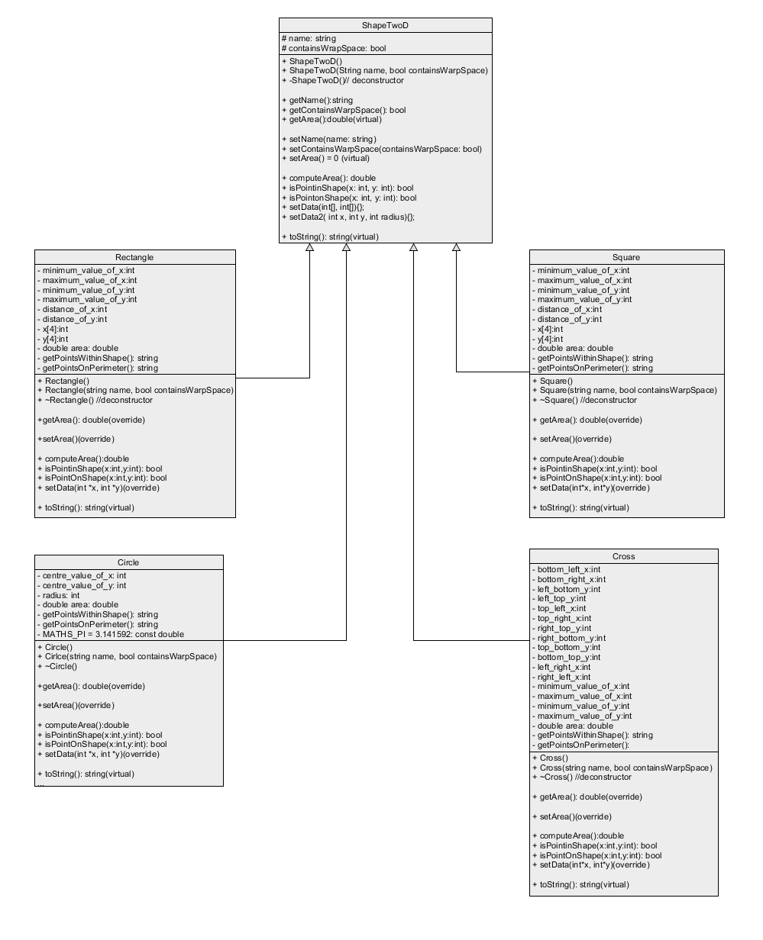
As I implemented the program, I focused on addressing the difference between characteristics and behaviors of different shapes—Circle, Square, Rectangle, and Cross. These shapes have their own unique properties and behaviors, and I ensured that my code encapsulated these specifics while promoting code reusability through encapsulation, polymorphism, and function overloading.

Starting with encapsulation, I encapsulated the attributes and methods of each shape within their respective classes. This approach helped maintain the integrity of the data by restricting direct access and manipulation, which help give the code a more controlled interaction with the shape objects. By encapsulating the shapes' properties and functionalities, I established a clear boundary between the workings of each shape.

Polymorphism played a key role in managing the different types of shapes in a unified manner. I achieved this through a common base class, `ShapeTwoD`, from which all other shape classes inherited. This allowed me to store various shape objects in the same vector and access their methods using polymorphic behavior. For instance, regardless of whether I was working with a Circle, Square, Rectangle, or Cross, I could call `computeArea()` method on each shape object, and the appropriate implementation would be invoked based on the specific type of shape.

Function overloading came into play when designing methods such as `processSquare_Rectangle_Cross_Shapes()`. By overloading this method, I streamlined the process of gathering points for Square, Rectangle, and Cross shapes. Depending on the number of sides, this method efficiently collected the coordinates and managed the formation of these shapes. This not only reduced code redundancy but also enhanced the code's readability.
To conclude, my implementation highlights how encapsulation, polymorphism, and function overloading are the cornerstone of object-oriented programming. These principles streamlined the management of diverse shapes, enhancing code structure and flexibility. This foundation not only organized the code effectively but also ensured its adaptability for future enhancements and modifications.

- REFLECTIONS
As I went through assignment 2 specification and on the implementation of the program, I encountered both exciting breakthroughs and complex challenges. Encapsulation and polymorphism were particularly pleasing. By structuring diverse shapes under a shared base class, I implemented polymorphism to streamline their methods, which helped in the organization of the code and versatility.
Yet, the Cross shape caused the most headaches. What initially seemed simple became very complex for me. Dividing the Cross into smaller components for area gave took so much of time. Additionally, defining "on shape" points within the Cross, like the corners of intersecting squares, required careful consideration. This experience underscored the importance of comprehensive understanding and precision when dealing with intricate geometries. I also learned the importance of compilation. It took some time to “test-case” the code for I also must understand the anatomy of the shapes.
In retrospect, being able to do the Cross was rewarding. It highlighted the need for meticulous design and thorough testing to avoid misconceptions. Assignment2 deepened my grasp of encapsulation, polymorphism, and function overloading, emphasizing clarity and precision in code development. The importance of understanding complexity of specifications greatly enhances my ability to view the world and my future endeavors.

- PROBLEMS
I don’t really have many problems, but I would like to know another way to do the cross. I felt that mine was more on the inefficient side. Was there a simpler way? How can I make things better? Are some of the questions I liked answer for it may help how I see the future better.
Figuring out specific x and y values to properly test-case is another problem for it took a lot of time, most specifically, for the cross to understand and make-up values.

